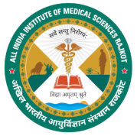
UNDERTAKING

I_________________________________________________________________________________ Son/Daughter of Mr./Mrs._____________________________________________________________ have passed UG NEET MBBS Entrance Examination held for academic year 2021-22

I certify that all my Original Certificates (i.e. 10th Passed/ Age proof, 12th Passed Marks Sheet and Certificate and Scheduled Caste / Scheduled Tribe (SC/ST) / Other Backward Class (OBC) are authentic. If any found false, then my candidature may be treated withdrawn/cancelled at any time during the course.

Name: ______________________________
Signature of the Candidate: _____________
Address: ____________________________ ________________________________________________________________________

