Dated :

To

The Executive Director
All India Institute of Medical Sciences (AIIMS),
Rajkot.
Pin: 360110

Sub: Submission of Joining Report.

Dear Sir,
With reference to your offer of appointment letter No. ………………….……. dated I
report myself on duty in the forenoon / afternoon of in the post
of ..................................
I thank you once again for providing me the opportunity to serve the Institute. I will perform my duties sincerely, honestly and to the best of my abilities.
Yours sincerely,
Name: ……………..………………………
Designation …….……………………….
Department …………………………….
Date of birth ……………………………

All India Institute of Medical Sciences, Rajkot – 360110
CHARACTER CERTIFICATE
Certified that I have known Mr./Ms./……………………………………… Son/daughter of Shri…..…………………………………

………….for the last………….years ……………….months. He/She bears a good moral character and is of

………………….nationality. He/She is not related to me.

Place: Signature

Date :

Name (in Capital Letters) Designation & Address with Stamp

This certificate should be from any one of the following:

- Gazetted Officer of Central or State Government;

- Members of Parliament or State Legislature belonging to the constituency where the candidate or his parent/ guardian is ordinarily resident;

- Sub-Divisional Magistrates/ Officers;

- Tehsildars or Naib/ Deputy Tehsildars authorized to exercise magisterial powers;

- Principal/Head Master of the recognized School/ College/ Institution where the candidate studied last;

- Block Development Officer;

- Post Masters; 8. P

- Panchayat Inspectors

All India Institute of Medical Sciences, Rajkot – 360110

DECLARATION

I, ……………………………………………………………………. Son / daughter of Shri ……………..………… ……………………………
resident of village / town/ city ………………………district …………….…….…… State hereby
declare that I belong to the …………………. Community, which is recognized as a backward class by the Government of India for the purpose of reservation in services as per orders contained in Department of Personnel and Training Office Memorandum No. 36012/22/93-Estt.(SCT), dated 08.09.1993. It is also declared that I do not belong to persons/ sections (Creamy Layer) mentioned in Column 3 of the Schedule to the above- referred Office Memorandum, dated 08.09.1993.

Date:

Signature of the candidate

Name & permanent address

…………………………………..

…………………………………..

…………………………………..

(Note: To be filled by OBC category only)

All India Institute of Medical Sciences, Rajkot – 360110

UNDERTAKING

- The furnishing of the false information or suppression of factual information in on my joining would be a disqualification and is likely to render the candidate unfit or employment under the Government.

- If the fact that false information has been furnished or that there has been suppression of any factual information comes to notice at any time during the service, I would be liable to be terminated.

- The experiences as mentioned on my online application are teaching/research experiences and the same is recognized by MCI/Govt. of India. In case it is found that the same is not recognized by MCI/GOI at any stage, my appointment may be cancelled.

- I also declare that I possess all requisite qualification and experiences as per the requirement of the advertisement and in case it is found that I am not fulfilling any eligibility criteria, my appointment may be treated as cancelled.

Signature with Date Name :

AFFIDAVIT
(to be executed on non-judicial stamp paper of Rs. 100/-)

I Dr. age years, Son of resident of

, do hereby solemnly affirm and state as under:-

  - That I am the deponent of this affidavit.
  - That I do hereby declare that I am not indulged or doing private practice of any kind including laboratory and consultant practice.
  - That presently I am not working at any other Institutions or Medical College or Government/Autonomous/Semi Government Organization. I have been relieved by the Institution where I was working previously before joining AIIMS Rajkot.
  - That I have passed MBBS in the year and MD in the year .
  - That I am not drawing any salary/pension from any source other than AIIMS, Rajkot.
  - That the affidavit is required to be produced before The Executive Director, AIIMS, Rajkot for necessary action.
  - That all educational qualifications and teaching/research experiences are from MCI recognized Institutes/college.

That the facts stated above are true to the best of knowledge and belief.

Date Deponent

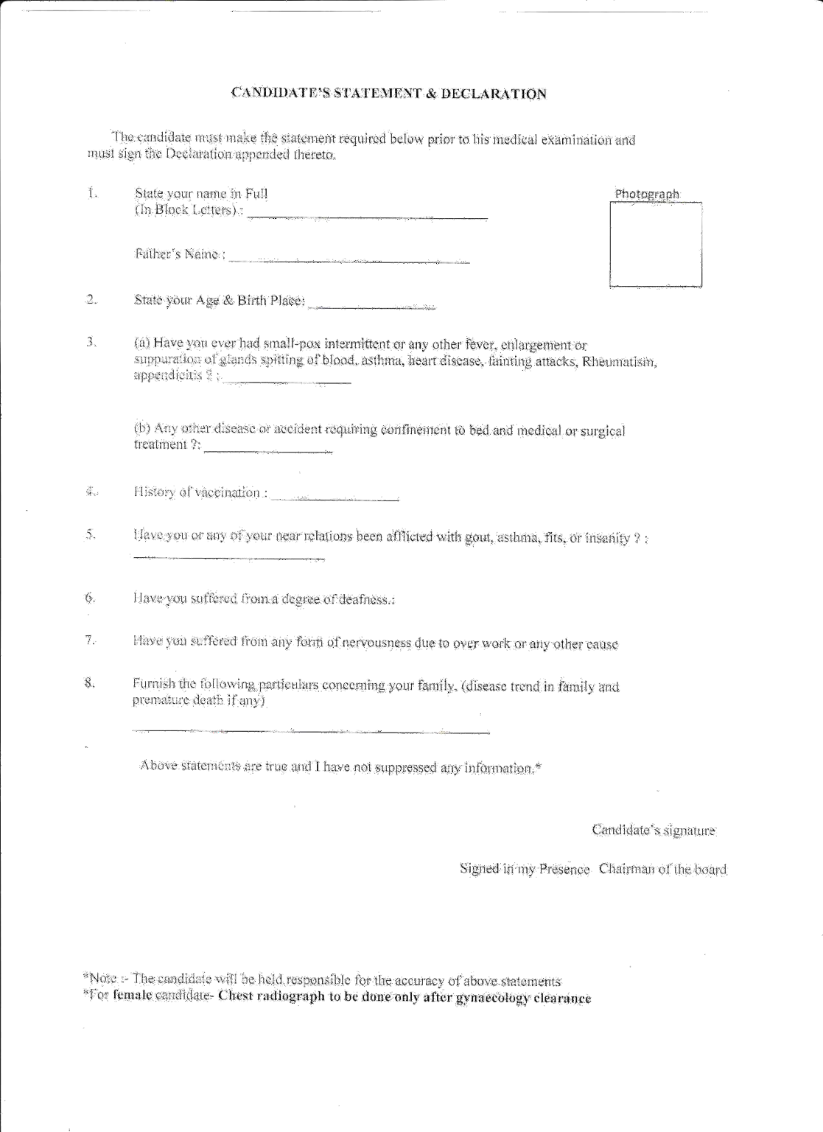

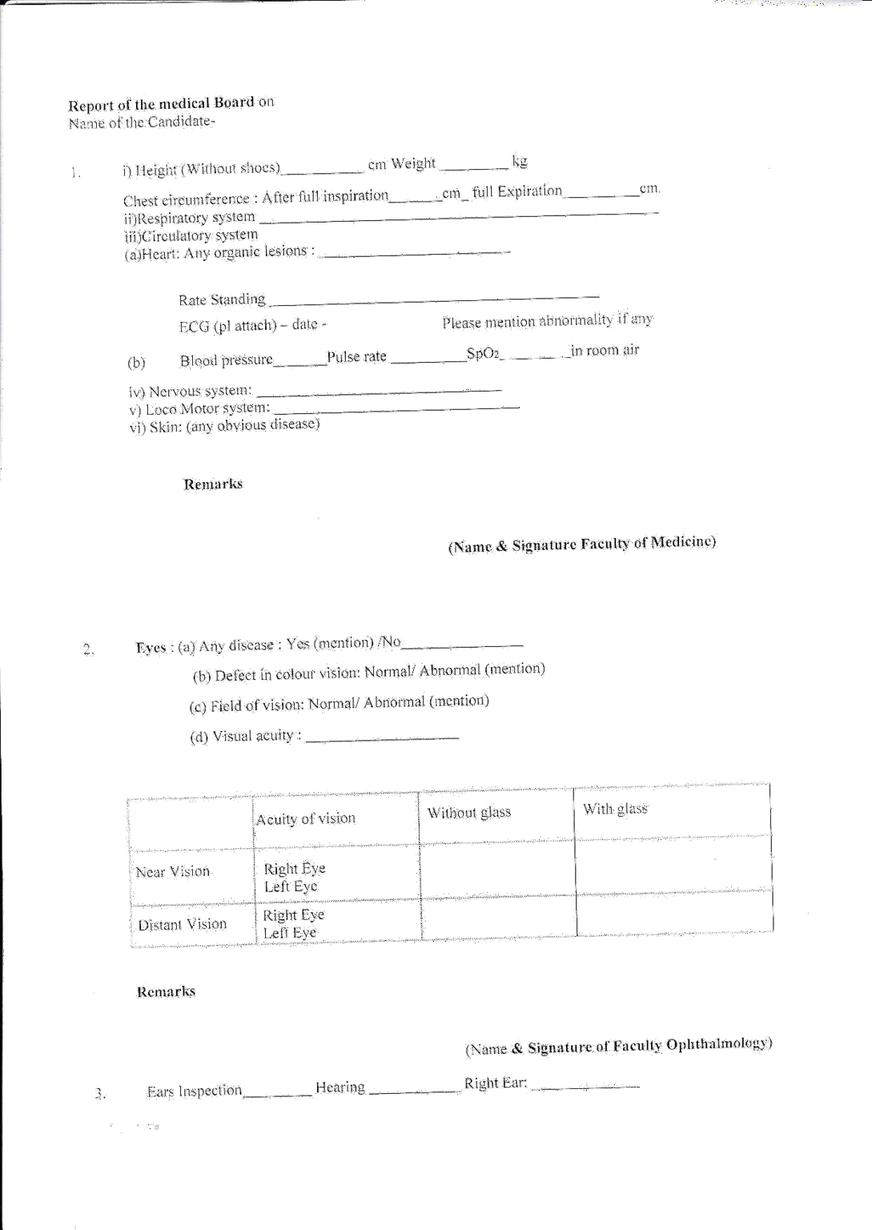

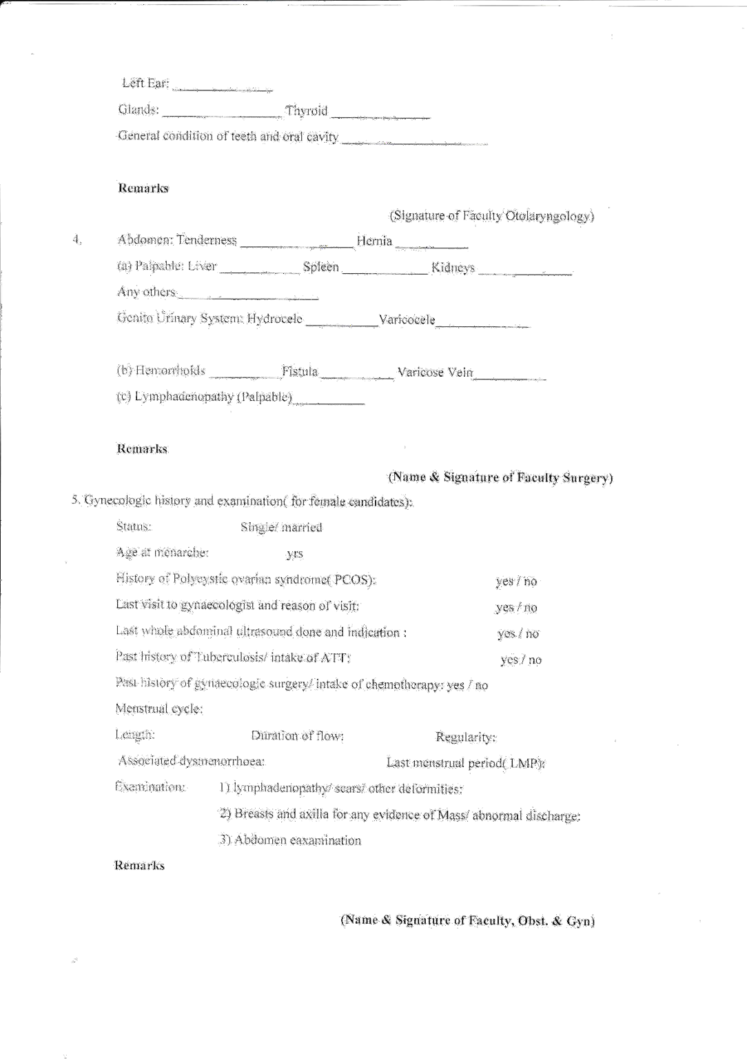

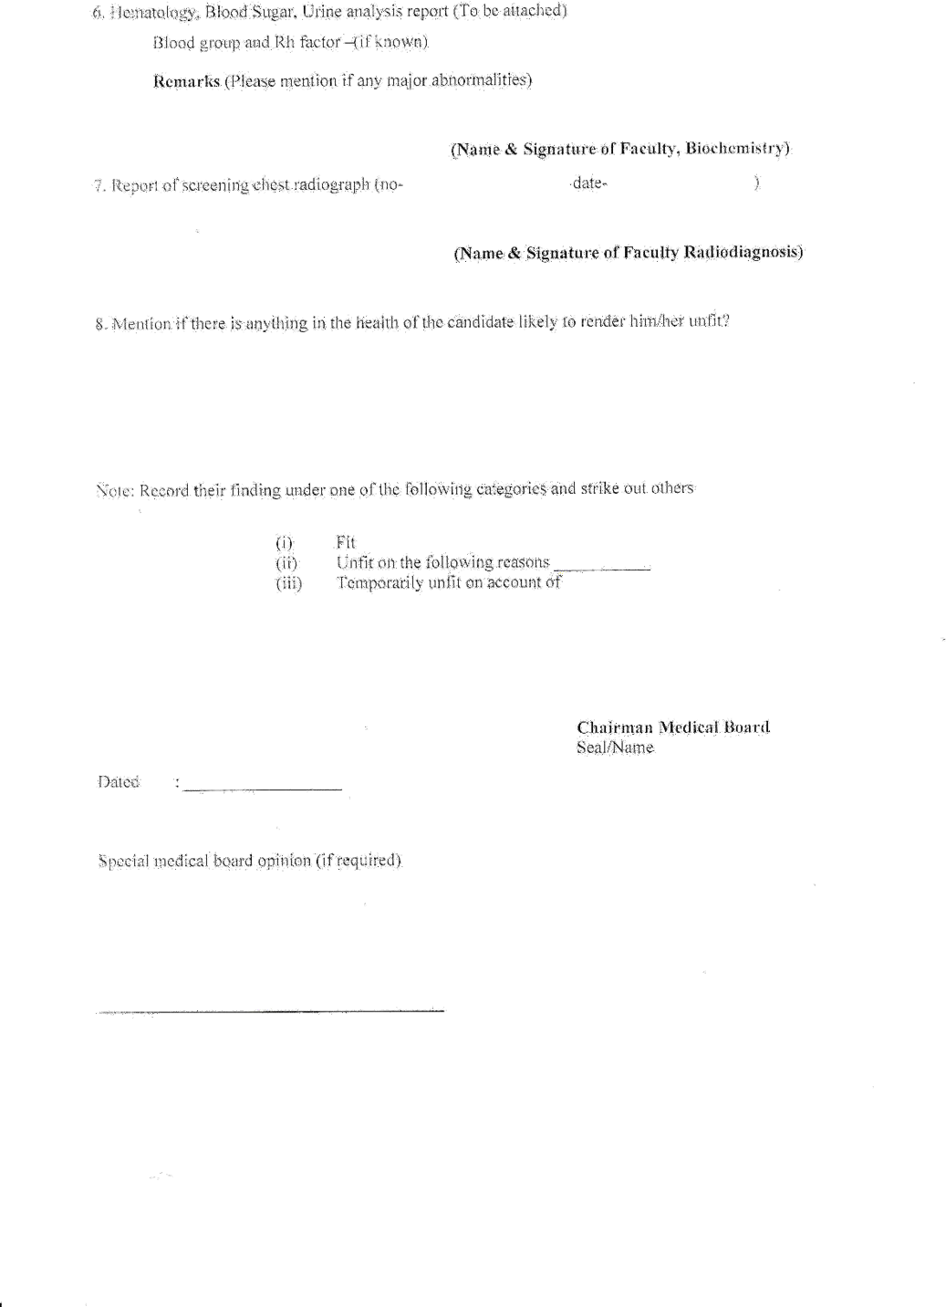

Police verification/attestation form

WARNING:-

ATTESTATION FORM

    - The furnishing of false information or suppression of any factual information in the Attestation Form would be a disqualification and is likely to render the candidate unfit for employment under the Govt.

Affix passport size photograph here

    - If detained, arrested, prosecuted, bound down, fined, convicted, debarred, acquitted, etc., subsequent to the completion and submission of this form, the details should be communicated immediately to the authorities to whom the attestation form has been sent early, failing which
it will be deemed to be a suppression of factual information.

- If the fact that false information has been furnished or there has been suppression of any factual information in the attestation form comes to notice at a time during the service of a person, his/her services would be liable to be terminated.

- Name in full (IN BLOCK CAPITALS) :
with alias, if any. (Please indicate if you have added or dropped in any stage any part of your name or surname)

- Present address in full :
(i.e. Village / Thana / District or House No./ Lane/ Street / Road / Town and name of District Hqrs.)

- (a) Home address in full :
(i.e. Village / Thana /District or House No./Lane / Street / Road / Town and name of District Hqrs.)

- If originally a resident of Pakistan, the address in
that country and the date of migration to Indian Union :

- Particulars of places (with period of residence) where you have resided for more than one year at a time during the preceding five years. In case of stay abroad (including Pakistan) particulars of all places where you have resided for more than one year after attaining the age of 21 years should be given.

 |  |  |  | Name of the Hqrs. of the places mentioned in the preceding column
S. No. | From | To | Residential address in full (i.e. Village / Thana / District or Door No. / Lane / Street / Road and Town)

Members of family | Name (with alias, if any) | Nationality | Place of Birth | Occupation (if employed, give designation and Office address | Present postal address and permanent Home address
 | 1 | 2 | 3 | 4 | 5
Father
Mother
Wife / Husband
Brother/s
Sister/s

- Information to be furnished with regard to son(s) and daughter(s) in case they are studying / living in a foreign country.
Name | Nationality (By birth or Domicile) | Place of birth | Country in which studying/living with full address | Date from which studying in the country mentioned in previous column

- Nationality (by birth or Domicile) :

- (a) Date of birth :

- Present age :

  - Age at Matriculation :

- (a) Place of Birth/District & State in which situated :

- District & State to which you presently belong :

- Distt & State to which your father originally belonged :

- (a) Your religion :

- Are you a member of SC / ST / OBC :
(strike out whichever not applicable)

- Name of the Caste :

- Category of candidature (PH / EX-SM / Dependents of EX-SM killed in action)
: (strike out whichever not applicable)

- Educational qualification showing places of education with years in School(s) and Colleges(s) since 15th year of age.

Name of School/ College with full address | Date of entrance | Date of leaving | Examination(s) passed

- (a) Are you holding or have any time held an appointment under the Central or State Government or a Semi-Government or a Quasi-Government body or an Autonomous body or a public undertaking or a private firm or institution. If, so, give full particulars with dates of employment, up-to- date.

Period |  | Designations, Emoluments and nature of  employment | Full name and address of the employer | Reasons for leaving previous service
From | To

- If the previous employment was under the Government of India / a State Government / an Undertaking owned by or controlled by the Government of India or a State Government /an autonomous body / University / local body.

(state whether you had left service on giving a month’s notice under Rule 5 of Central Civil Services (Temporary Service ) Rules, 1965, or any similar corresponding rules where any disciplinary proceedings framed against you, or had you been called upon to explain you conduct in any matter at the time you have been served with notice of termination of service, or at a subsequent date, before your services were actually terminated).

- (a) Have you ever been arrested?

  - Have you ever been prosecuted?

  - Have you ever been kept under detention?

  - Have you ever been bound down?

  - Have you ever been fined by a Court of Law?

  - Have you ever been convicted by a Court of Law for any offence?

  - Have you ever been debarred from any examination or restricted by any University or any other educational Authority / Institution?

  - Have you ever been debarred / disqualified by any Public Service Commission/Staff Selection Commission for any of its examinations / selections?

  - Is any case pending against you in any University or any other Educational Authority / Institution at the time of filling up this Attestation Form?
: Yes / No

: Yes / No

: Yes / No

: Yes / No

: Yes / No

: Yes / No

: Yes / No

: Yes / No

: Yes / No

  - Is any case pending against you in : Yes / No any Court of law at the time of filling
up this Attestation Form?

  - Whether discharged/expelled/ : Yes / No withdrawn from any training institution
under the Govt. or otherwise?

If the answer to any of the above mentioned questions is “Yes”, give full particulars of the case Viz. arrest/ detention/ fine/ conviction/ sentence/ punishment, etc., and the nature of the case pending in the Court/ University/ Educational authority, etc. at the time of filling up of this form.

NOTE : (i) Please also see the ‘WARNING’ at the top of this form.

(ii) Specific answers to each of the questions should be given by striking out “Yes” or “No” as the case may be.

- Name and addresses of two responsible persons of your locality or two references to whom you are well known.

(1)

(2)

I CERTIFY THAT THE FOREGOING INFORMATION IS CORRECT AND COMPLETE TO THE BEST OF MY KNOWLEDGE AND BELIEF. I AM NOT AWARE OF ANY CIRCUMSTANCES WHICH MIGHT IMPAIR MY FITNESS FOR EMPLOYMENT UNDER THE GOVERNMENT OF INDIA.

Date :

Place : Signature of the candidate/ employee

