Department of Paediatrics and Adolescent Medicine

World Obesity Day 2023 in AIIMS Rajkot
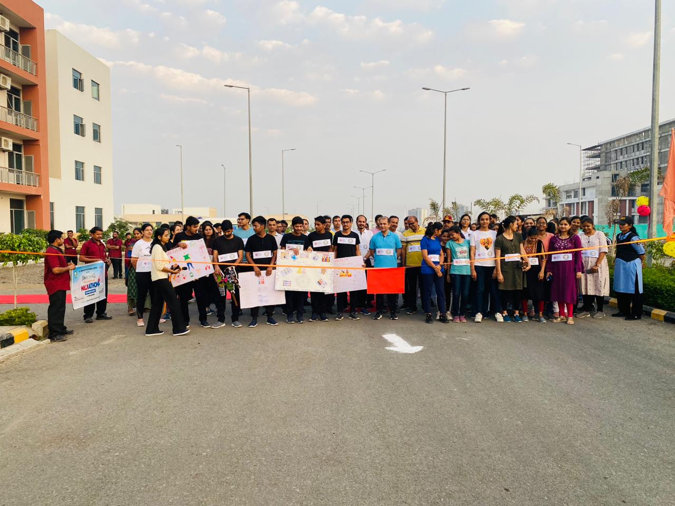

The department of Paediatrics & adolescent medicine observed World Obesity Day on 4th March, 2023, to promote awareness about obesity and related issues. The theme for this year was “Obesity : changing perspectives, let’s talk about obesity”
The day was marked by following events
- A walkathon in AIIMS khanderi Campus at 7 am from OPD to Hostel premises. It started with welcome note by Dr Pinky Meena. The walkathon was graced by presence of respected Col Puneet Arora, Deputy Director Administration, AIIMS Rajkot who inaugurated the walk by ribbon cutting. Dr Bhavesh Modi Prof and Head Community Medicine presented few facts related to the prevalence of obesity and the epidemic that it is growing into. the walkathon received a footfall of more than 150 participants including faculty, MBBS students, nursing and allied staff from hospital.
https://twitter.com/aiimsrajkot/status/1631988228491452417?t=W8aoD2f40VKZGmD_CDCjvA&s=08

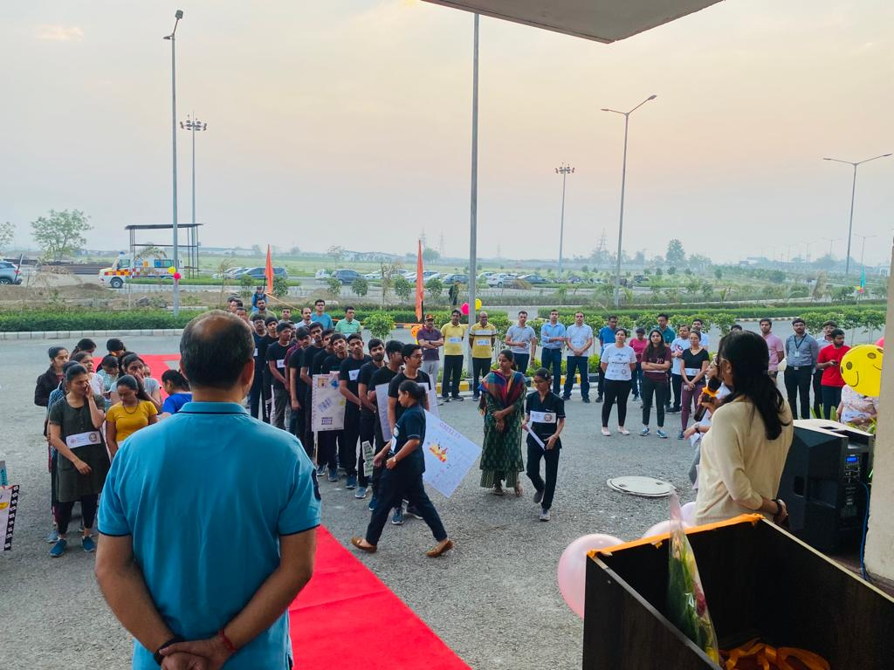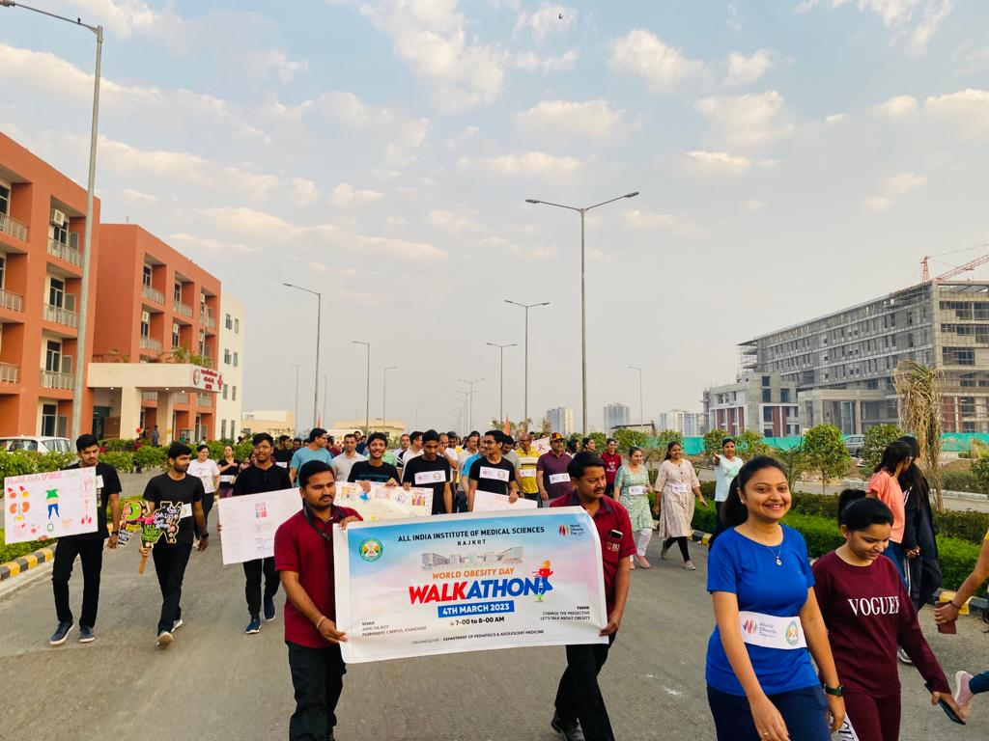
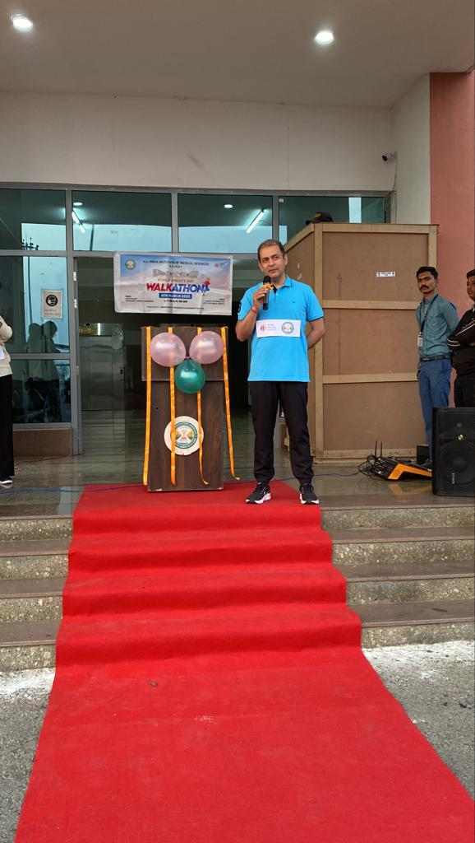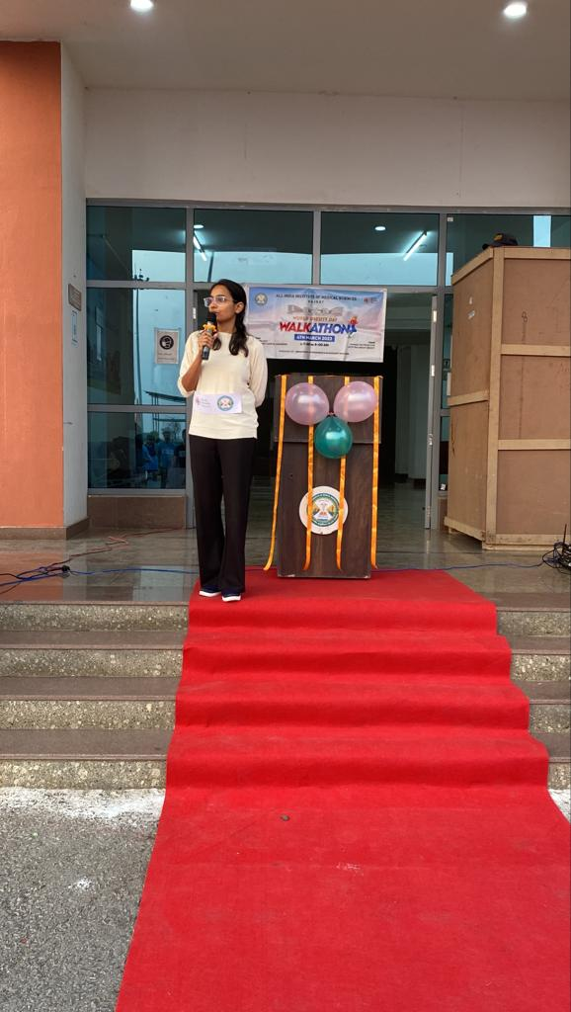

- Roleplay by the Nursing staff, moderated by Dr Pinky Meena. The roleplay highlighted the importance of acting for obesity in an holistic manner and paying attention to lifestyle modification and nutrition right from childhood. The causative factors and complications of obesity were presented in crisp and easy language for general population. It incorporated the behavioural changes required to tackle obesity in an effective way. The Role play was also performed in Para pipaliya village, under AIIMS outreach program where it was well received by general population.
https://twitter.com/aiimsrajkot/status/1631987543330922496?t=h47vqrqj7fNAiSBfyQR88Q&s=08

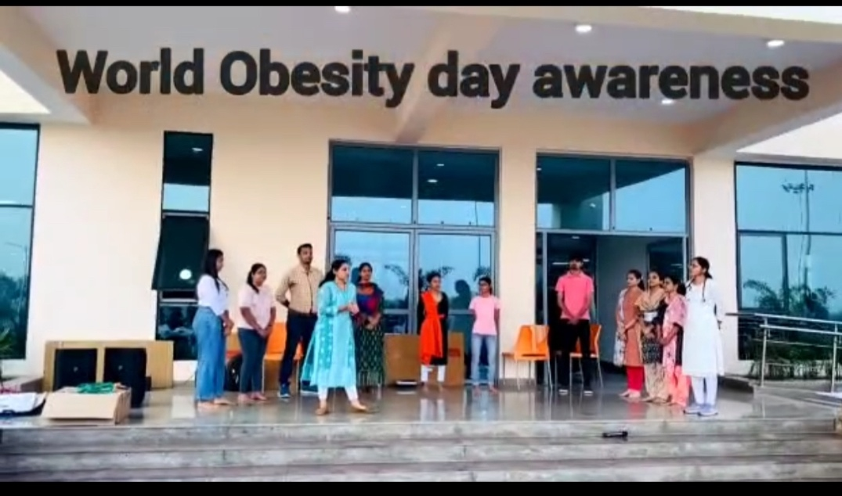

- Poster & slogan making competition was held in OPD campus and hostel premises, AIIMS RAJKOT on 4th March. MBBS students , nursing staff participated in the same. The posters highlighted the vicious cycle of obesity, causative factors, taboos related to obesity, complexity of obesity, and behavioural changes required to tackle it. The posters brought out vivacity in health campaign and they were displayed in the OPD campus throughout the day. The competition was judged by Dr Sanjay Gupta Prof and HOD Forensic Medicine, Dr Ashwini Aggarwal Prof and HOD Microbiology, and Dr Bhavesh Modi Prof and HOD Community Medicine. The Winners were distributed certificates for appreciation.
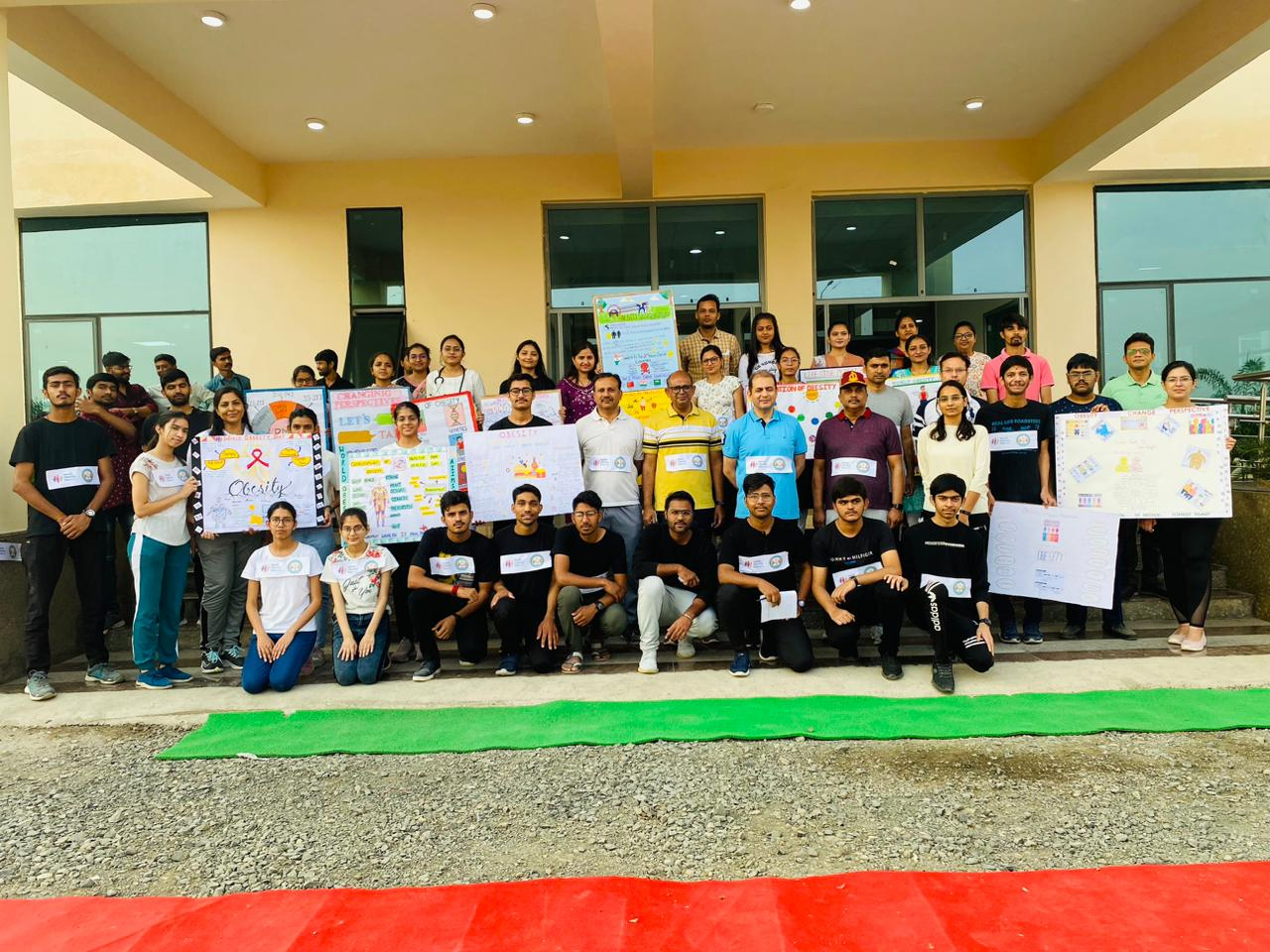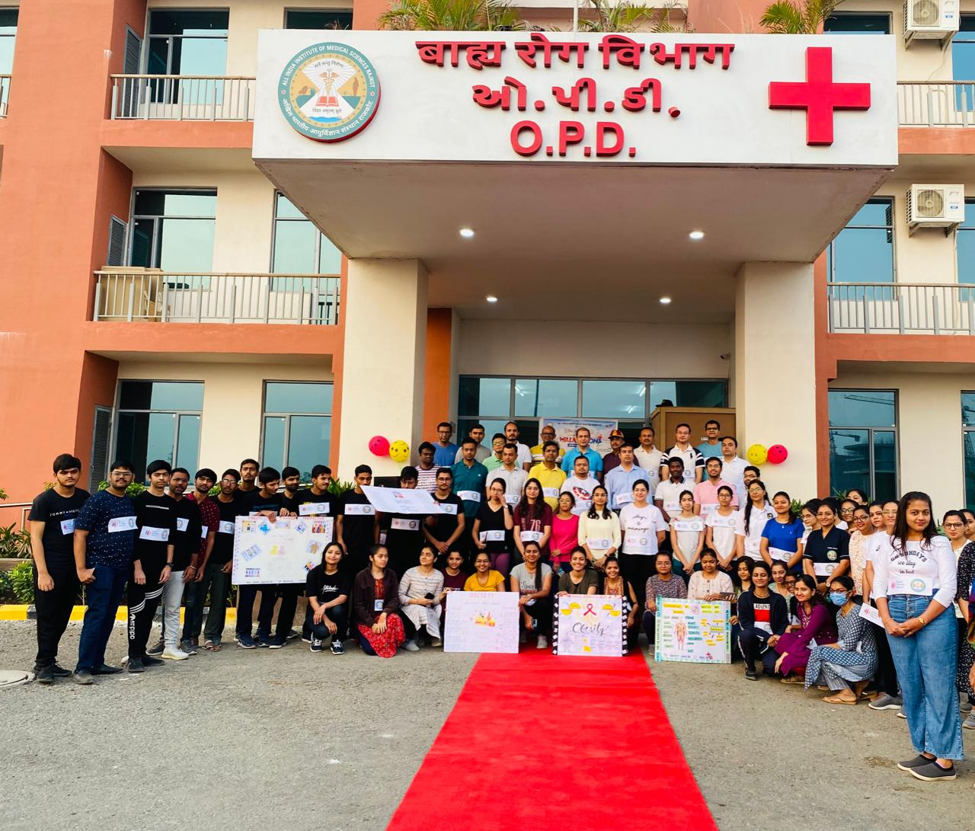

- Healthy Snacks (Millets): In a bid to exemplify healthy eating and promote the government’s initiative to promote consumption of millets worldwide a healthy fresh millet based snacks were arranged for all attendees.
https://twitter.com/aiimsrajkot/status/1632016416206618624?t=6-6ccYAfPYK8F_-g05swfQ&s=08

- Plantation : the awareness activity involved tree plantation to mark the day as reminder to adopt the behavioural changes required to tackle obesity.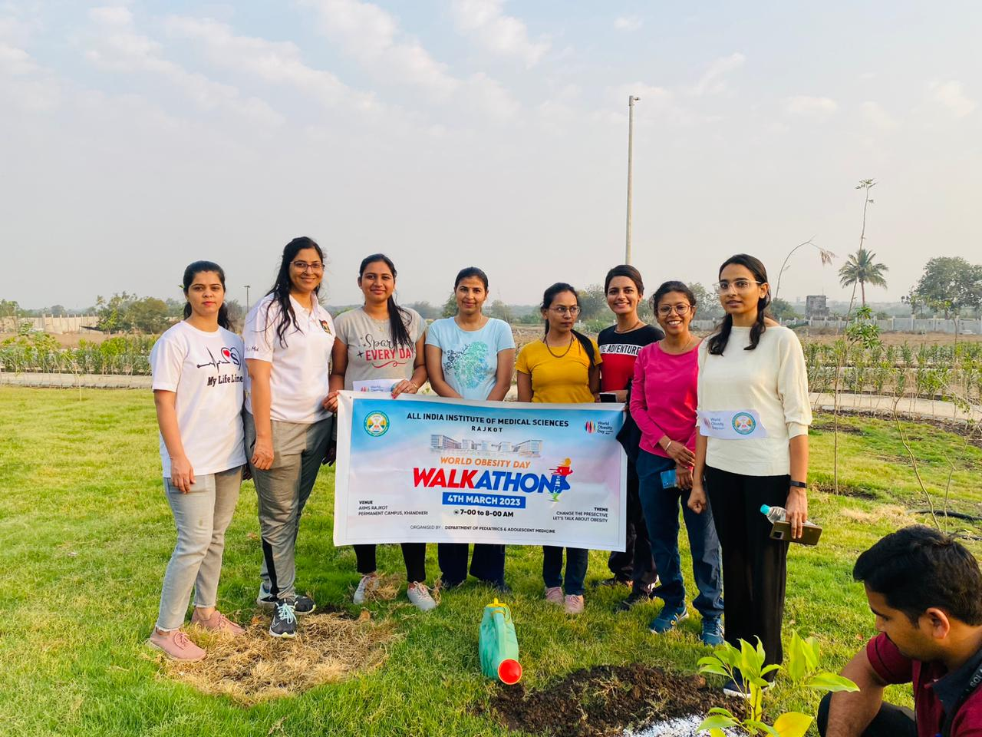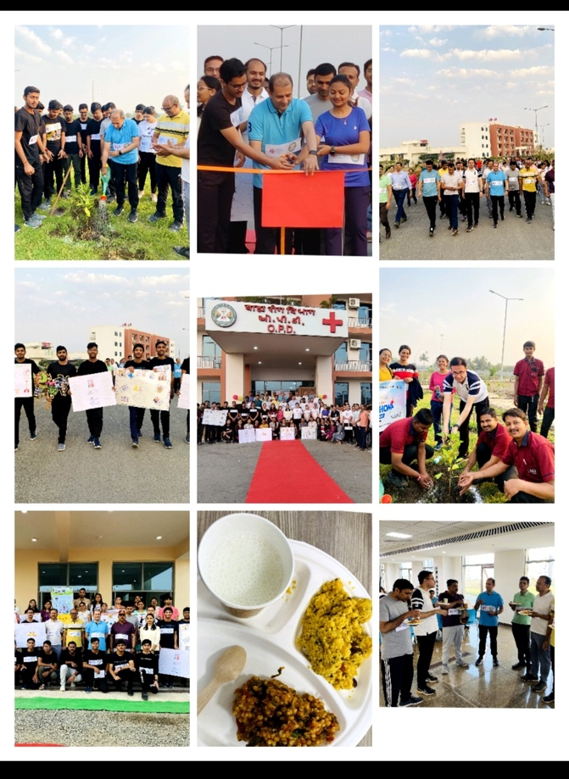
The awareness event concluded with a positive note on commencing dialogue to tackle obesity amongst all stakeholders. It was successful in demonstrating practical ways to bring required behavioural changes.

