**All India Institute of Medical Sciences, Rajkot (Gujarat)**

**Department of Anatomy**

**Model Exhibition**

**on**

**‘Head, Neck, Face region and related neuro-vascular structures’**

**Summary Report of Anatomy Model Exhibition**

The Department of Anatomy, AIIMS Rajkot conducted a Model exhibition on **Head, Neck, Face and related neuro-vascular structures’**on Thursday, 20th June 2024 from 11.00 AM to 13.00 PM. **Professor Col. Dr. CDS Katoch**, Executive Director, AIIMS Rajkot was the Chief Guest of the event. Deputy Director (Admin), **Col. Puneet Kumar Arora**, also graced the occasion. The program was conducted under the guidance of Organizing Chairperson **Dr. Simmi Mehra**, Professor & Head, Department of Anatomy; and Co-ordinated by Dr. Rohin Garg, Dr. Sundip Charmode, Dr. Pradip Chauhan, Dr. Lalit Ratanpara and Dr. Neha Xalxo. They were assisted by the Junior residents, Dr. Valency and Dr. Rajdeep in the various event related activities.

**Objective of the Competition:** The objective of this exhibition was to emphasise the clinical importance and conceptual visualization of structures in the head, neck and face region along with related neuro-vascular structures to the first-year MBBS students, thereby instilling a clinical-oriented learning approach.

**Program details:**

All the First year MBBS students were divided in 16 groups. Each group, comprising of 3-4 students, was allotted a topic for model preparation. All the students (group wise) were stationed along with their respective models in the Dissection hall of the Department of Anatomy. All the faculty members, and residents were invited for the event.

The program started at 11.00 am by a warm welcome to the Chief Guest by **Dr. Simmi Mehra,** Professor and Head, Department of Anatomy, AIIMS, Rajkot.

The Exhibition of Models was inaugurated by **Professor Col. Dr. CDS Katoch, Executive Director AIIMS Rajkot**.

**Professor Col. Dr. CDS Katoch,** the Chief Guest, interacted with each student group, posing clinical questions pertaining to their models. He imparted his extensive expertise by discussing a variety of fascinating cases with the attendees, including both students and faculty. E.D. Sir, strongly recommended and laid stress on the importance of augmenting students' foundational clinical oriented skills to equip them for managing clinical cases in the latter stages of their education.

**Some moments captured during exhibition (20th June 2024)**

The Organizing Chairperson with Executive Director Sir and Deputy Director Sir

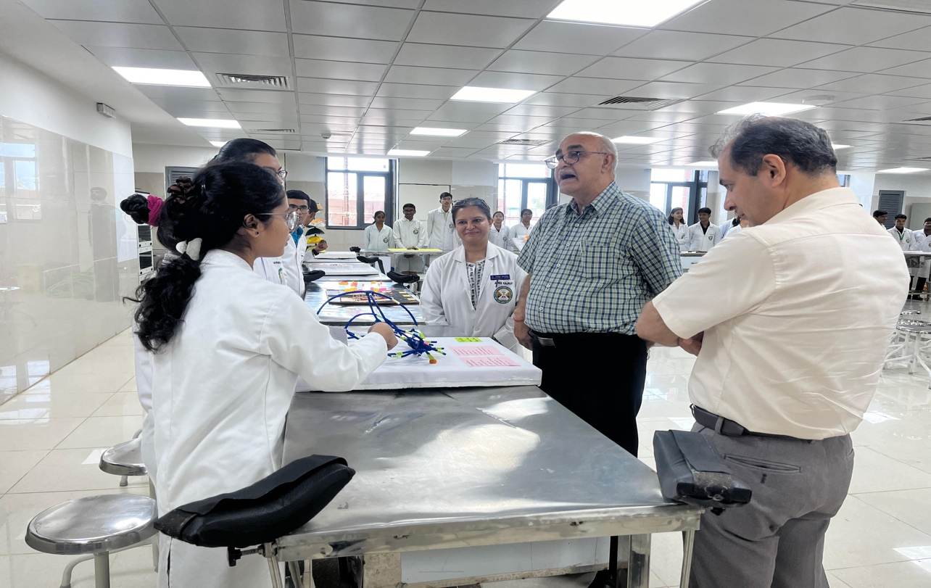

The Executive Director Sir guiding the students

The students presenting their models

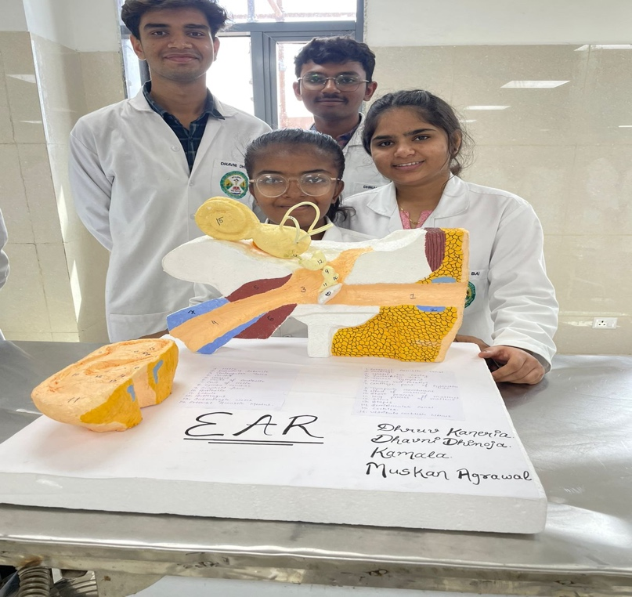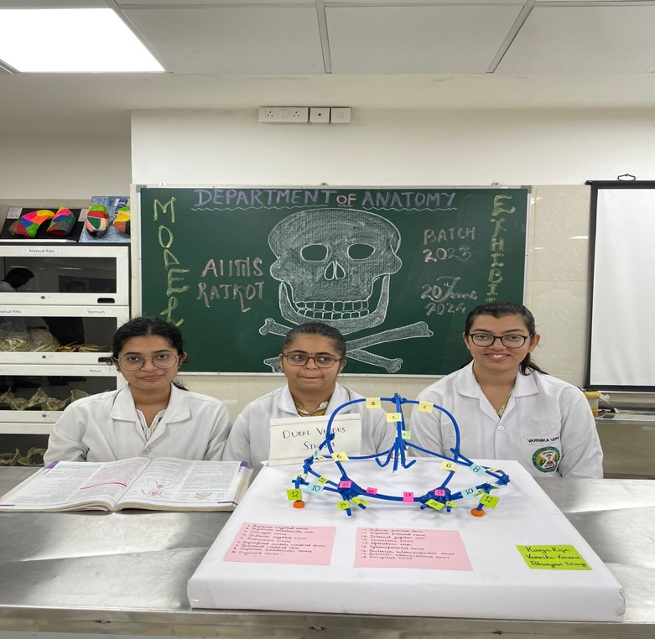

Panoramic view of the dissection hall showing all the students stationed at their places with their models

The Executive Director Sir evaluating the models

The faculty members interacting with the students

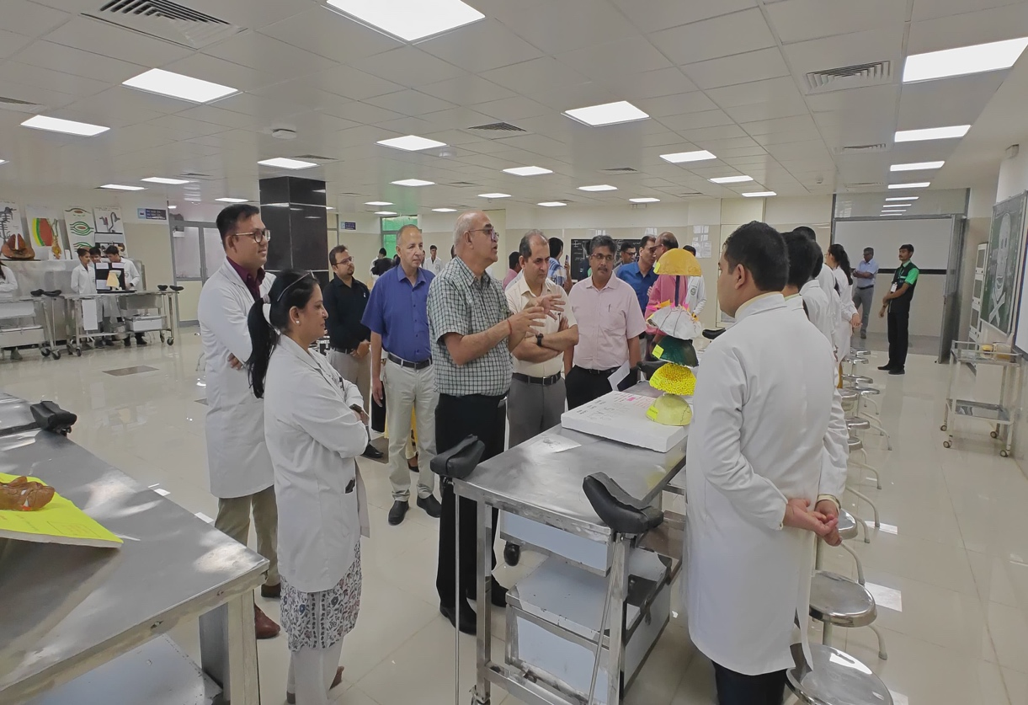

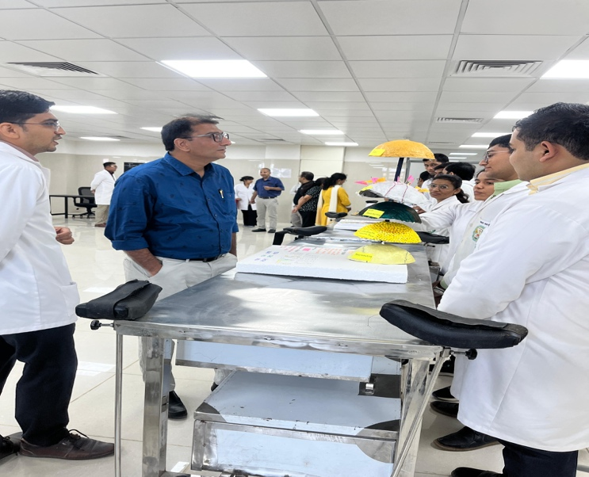

On behalf of the whole organizing committee, I sincerely thank Executive Director Sir for all the blessings, support, and motivation to successfully conduct the exhibition.

We are grateful to you Sir.

Thanks, and Regards

Dr. Simmi Mehra

Professor and Head

Department of Anatomy

AIIMS Rajkot